Dock Levelers | 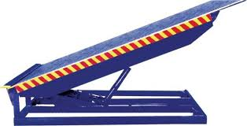
Make | NIHVA
Capacity in KG | 6000/9000/10000/12000/15000
Platform Width in MM | 2030
Platform Length in MM | 2720
Lip Width in MM | 2030
Lip Length in MM | 400
Working Length (Including Lip) in MM | Direct by electric Motor
Overall Length in MM | 2720
Overall Width in MM | 2030
Shut Height in MM | 485
Working Range UP/Down in MM | (+) 300 / (-) 250
Loading Platform Height from Road in MM | 1250
Dock Operation Mode | AC Power Pack Hydraulically Operated
Lip Operation Mode | Hydraulically Operated
Operation Control | Through Panel
Power Pack | Hydraulic
Drive Type | Direct by electric Motor
Motor Ratings HP / Make | 1HP/Crompton
Pump Design Flow (LPM) | 2.5
Pump Type | Gear
Safety Valve Set Pressure (Kg/Sq. Cm) | 120
Volume of Oil Receiver (Liter) | 7
No. Of Deck Cylinder | 1 / 2 (optional)
No. Of Lip Cylinder | 1
Power Supply | 3 Phase
Maximum Gradient | 1:10
Clear Pit Dimensions (W x L x D) MM | 2080 X 2780 X 485
Service Weight in Kg (Approx.) | 900
Colour | Golden Yellow

